BEP Work Cell Controller Debug Files Extraction

1. Click “Diagnostics” on the WCC application’s main screen.

2. The box below will appear

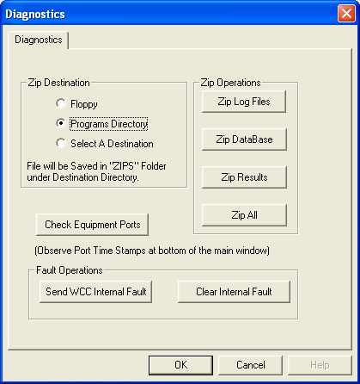
3. Under “Zip Destination”, select “Programs Directory”

4. Click the “Zip All” button

5. You may receive a message box with the message shown below. Click “Yes” if asked to do so by a Burke Porter representative. Otherwise click “No”



6. Some Command Prompt windows will appear while the files are being zipped. At the end of the operation, the windows will disappear.

7. Click OK to close the dialog

8. Go to the “C:\programs\ZIPS” folder.

9. You will find 3 zip files there: Results.zip, WCCData.zip and WCCLogs.ZIP

10. If you clicked Yes to zip daily logs, you will also find the zip file WCC_DAILY_LOGS.ZIP

11. Copy these zip files and send them to a Burke Porter representative.

